* Introduction to Internet

• How does Internet works?

• Internet addressing & DNS

• Internet Vs Intranet

* Internet is a global network that connects billions of computers across the world with each other and to the World Wide Web. It uses standard internet protocol suite (TCP/IP) to connect billions of computer users worldwide. It is set up by using cables such as optical fibers and other wireless and networking technologies.
* It is believed that the internet was developed by "Defense Advanced Projects Agency" (DARPA) department of the United States. And, it was first connected in 1969.
* The internet works with the help of clients and servers. A device such as a laptop, which is connected to the internet is called a client, not a server as it is not directly connected to the internet. However, it is indirectly connected to the internet through an Internet Service Provider (ISP) and is identified by an IP address,
* A server is a large computer that stores websites. It also has an IP address. A place where a large number of servers are stored is called a data center. The server accepts requests send by the client through a browser over a network (internet) and responds accordingly.
* To access the internet we need a domain name, which represents an IP address number, i.e., each IP address has been assigned a domain name. For example, youtube.com, facebook.com, paypal.com are used to represent the IP addresses. Domain names are created as it is difficult for a person to remember a long string of numbers. However, internet does not understand the domain name, it understands the IP address, so when you enter the domain name in the browser search bar, the internet has to get the IP addresses of this domain name from a huge phone book, which is known as [DNS](https://www.javatpoint.com/dns-full-form) (Domain Name Server).
* An [IP address](https://www.geeksforgeeks.org/difference-between-private-and-public-ip-addresses/) represents an Internet Protocol address. A unique address that identifies the device over the network. It is almost like a set of rules governing the structure of data sent over the Internet or through a local network.
* **IP address structure:**IP addresses are displayed as a set of four digits- the default address may be 192.158.1.38. Each number on the set may range from 0 to 255. Therefore, the total IP address range ranges from 0.0.0.0 to 255.255.255.255.

IP address is basically divided into two parts:

* [**Network ID**](https://www.geeksforgeeks.org/finding-network-id-of-a-subnet-using-subnet-mask/)  
  It is the part of the left-hand IP address that identifies the specific network where the device is located. In the normal home network, where the device has an IP address 192.168.1.32, the 192.168.1 part of the address will be the network ID.
* Host ID

The host ID is part of the IP address that was not taken by the network ID. Identifies a specific device (in the TCP / IP world, we call devices “host”) in that network.

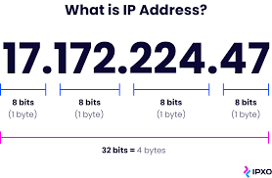

# DNS

* DNS is a service that translates the domain name into IP addresses. This allows the users of networks to utilize user-friendly names when looking for other hosts instead of remembering the IP addresses.
* For example, suppose the FTP site at EduSoft had an IP address of 132.147.165.50, most people would reach this site by specifying ftp.EduSoft.com. Therefore, the domain name is more reliable than IP address
* DNS is a TCP/IP protocol used on different platforms. The domain name space is divided into three different sections: generic domains, country domains, and inverse domain.

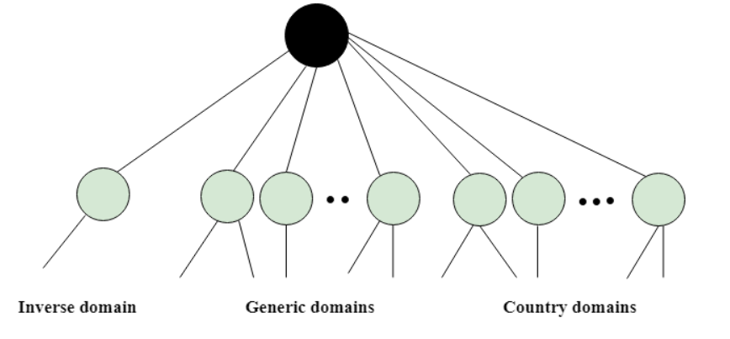

## **Generic Domains**

* It defines the registered hosts according to their generic behavior.
* Each node in a tree defines the domain name, which is an index to the DNS database.
* It uses three-character labels, and these labels describe the organization type.

|  |  |
| --- | --- |
| aero | Airlines and aerospace companies |
| biz | Businesses or firms |
| com | Commercial Organizations |
| coop | Cooperative business Organizations |
| edu | Educational institutions |
| gov | Government institutions |
| info | Information service providers |
| int | International Organizations |
| mil | Military groups |
| museum | Museum & other nonprofit organizations |
| name | Personal names |
| net | Network Support centers |
| org | Nonprofit Organizations |
| pro | Professional individual Organizations |

# 

## **Country Domain**

The format of country domain is same as a generic domain, but it uses two-character country abbreviations (e.g., us for the United States) in place of three character organizational abbreviations.

## **Inverse Domain**

The inverse domain is used for mapping an address to a name. When the server has received a request from the client, and the server contains the files of only authorized clients. To determine whether the client is on the authorized list or not, it sends a query to the DNS server and ask for mapping an address to the name.

Switching

* When a user accesses the internet or another computer network outside their immediate location, messages are sent through the network of transmission media. This technique of transferring the information from one computer network to another network is known as **switching**.
* Switching in a computer network is achieved by using switches. A switch is a small hardware device which is used to join multiple computers together with one local area network (LAN).
* Network switches operate at layer 2 (Data link layer) in the OSI model.

## **Why is Switching Concept required?**

Switching concept is developed because of the following reasons:

* **Bandwidth:** It is defined as the maximum transfer rate of a cable. It is a very critical and expensive resource. Therefore, switching techniques are used for the effective utilization of the bandwidth of a network.
* **Collision:** Collision is the effect that occurs when more than one device transmits the message over the same physical media, and they collide with each other. To overcome this problem, switching technology is implemented so that packets do not collide with each other.

# Switching techniques

In large networks, there can be multiple paths from sender to receiver. The switching technique will decide the best route for data transmission.

## **Circuit Switching**

* Circuit switching is a switching technique that establishes a dedicated path between sender and receiver.
* In the Circuit Switching Technique, once the connection is established then the dedicated path will remain to exist until the connection is terminated.
* Circuit switching in a network operates in a similar way as the telephone works.
* A complete end-to-end path must exist before the communication takes place.
* In case of circuit switching technique, when any user wants to send the data, voice, video, a request signal is sent to the receiver then the receiver sends back the acknowledgment to ensure the availability of the dedicated path. After receiving the acknowledgment, dedicated path transfers the data.
* Circuit switching is used in public telephone network. It is used for voice transmission.
* Fixed data can be transferred at a time in circuit switching technology.

**Communication through circuit switching has 3 phases:**

* Circuit establishment
* Data transfer
* Circuit Disconnect

# Switching techniques

**Advantages Of Circuit Switching:**

* In the case of Circuit Switching technique, the communication channel is dedicated.
* It has fixed bandwidth.

**Disadvantages Of Circuit Switching:**

* Once the dedicated path is established, the only delay occurs in the speed of data transmission.
* It takes a long time to establish a connection approx 10 seconds during which no data can be transmitted.
* It is more expensive than other switching techniques as a dedicated path is required for each connection.

## **Message Switching**

* Message Switching is a switching technique in which a message is transferred as a complete unit and routed through intermediate nodes at which it is stored and forwarded.
* In Message Switching technique, there is no establishment of a dedicated path between the sender and receiver.
* The destination address is appended to the message. Message Switching provides a dynamic routing as the message is routed through the intermediate nodes based on the information available in the message.
* Message switches are programmed in such a way so that they can provide the most efficient routes.
* Each and every node stores the entire message and then forward it to the next node. This type of network is known as **store and forward network.**
* Message switching treats each message as an independent entity.

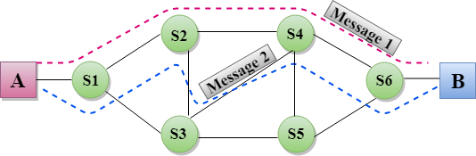

**Advantages Of Message Switching**

* Data channels are shared among the communicating devices that improve the efficiency of using available bandwidth.
* Traffic congestion can be reduced because the message is temporarily stored in the nodes.
* Message priority can be used to manage the network.
* The size of the message which is sent over the network can be varied. Therefore, it supports the data of unlimited size.

**Disadvantages Of Message Switching**

* The message switches must be equipped with sufficient storage to enable them to store the messages until the message is forwarded.
* The Long delay can occur due to the storing and forwarding facility provided by the message switching technique.

## **Packet Switching**

* The packet switching is a switching technique in which the message is sent in one go, but it is divided into smaller pieces, and they are sent individually.
* The message splits into smaller pieces known as packets and packets are given a unique number to identify their order at the receiving end.
* Every packet contains some information in its headers such as source address, destination address and sequence number.
* Packets will travel across the network, taking the shortest path as possible.
* All the packets are reassembled at the receiving end in correct order.
* If any packet is missing or corrupted, then the message will be sent to resend the message.
* If the correct order of the packets is reached, then the acknowledgment message will be sent.

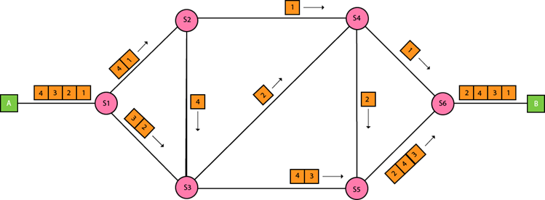

**Advantages Of Packet Switching:**

* **Cost-effective:** In packet switching technique, switching devices do not require massive secondary storage to store the packets, so cost is minimized to some extent. Therefore, we can say that the packet switching technique is a cost-effective technique.
* **Reliable:** If any node is busy, then the packets can be rerouted. This ensures that the Packet Switching technique provides reliable communication.
* **Efficient:** Packet Switching is an efficient technique. It does not require any established path prior to the transmission, and many users can use the same communication channel simultaneously, hence makes use of available bandwidth very efficiently.

**Disadvantages Of Packet Switching:**

* Packet Switching technique cannot be implemented in those applications that require low delay and high-quality services.
* The protocols used in a packet switching technique are very complex and requires high implementation cost.
* If the network is overloaded or corrupted, then it requires retransmission of lost packets. It can also lead to the loss of critical information if errors are nor recovered.

# Types of Internet Connection

There are many connections that can be used for internet access. All the connections have their own speed range that can be used for different purposes like for home, or for personal use

### Dial-Up Connection

* A [dial-up connection](https://www.geeksforgeeks.org/difference-between-dialup-and-broadband-connection/) is established between your computer and the ISP server using a modem.
* A dial-Up Connection is a cheap and traditional connection that is not preferred these days as this type of connection is very slow.
* To access the internet connection in the dial-up connection we need to dial a phone number on the computer and that’s why it requires a telephone connection. It requires a modem to set up a dial-up connection, which works as interference between your computer and the telephone line. In this connection, we can use either an internet connection or telephone at a time.

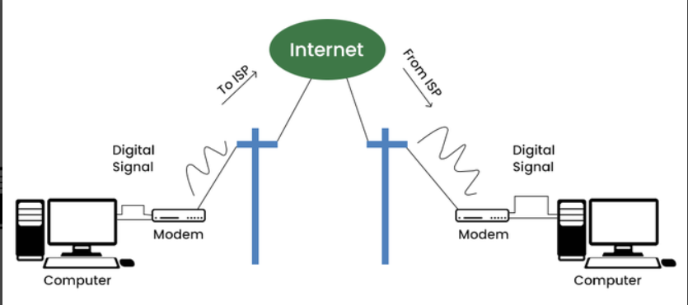

### Broadband Connection

Broadband refers to high-speed internet access that is faster than traditional dial-up access. It is provided through either cable or telephone composition. It does not require any telephone connection that’s why here we can use telephone and internet connection simultaneously. In this connection, more than one person can access the internet connection simultaneously.

It is a wide bandwidth data transmission that transports several signals and traffic types. In this connection, the medium used is coaxial cable, optical fiber cable, radio, or twisted pair cable.

Computer Network

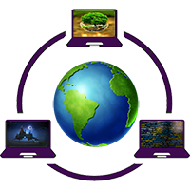

## **What is Computer Network?**

A computer network is a set of devices connected through links. A node can be computer, printer, or any other device capable of sending or receiving the data. The links connecting the nodes are known as communication channels.

Computer Network uses distributed processing in which task is divided among several computers. Instead, a single computer handles an entire task, each separate computer handles a subset.

### **Following are the advantages of Distributed processing:**

* **Security:** It provides limited interaction that a user can have with the entire system. For example, a bank allows the users to access their own accounts through an ATM without allowing them to access the bank's entire database.
* **Faster problem solving:** Multiple computers can solve the problem faster than a single machine working alone.
* **Security through redundancy:** Multiple computers running the same program at the same time can provide the security through redundancy. For example, if four computers run the same program and any computer has a hardware error, then other computers can override it.

# What is a Computer Network?

* **Computer Network** is a group of computers connected with each other through wires, optical fibres or optical links so that various devices can interact with each other through a network.
* The aim of the computer network is the sharing of resources among various devices.
* In the case of computer network technology, there are several types of networks that vary from simple to complex level.

## **Components Of Computer Network:**

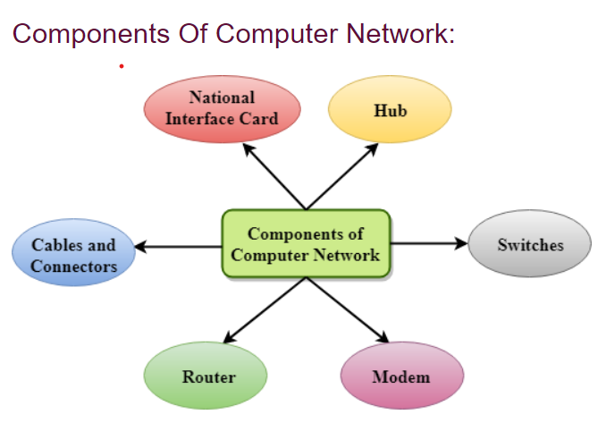

### **NIC(National interface card)**

NIC is a device that helps the computer to communicate with another device. The network interface card contains the hardware addresses, the data-link layer protocol use this address to identify the system on the network so that it transfers the data to the correct destination.

There are two types of NIC: wireless NIC and wired NIC.

* **Wireless NIC:** All the modern laptops use the wireless NIC. In Wireless NIC, a connection is made using the antenna that employs the **radio wave technology**.
* **Wired NIC:** Cables use the **wired NIC** to transfer the data over the medium.

### **Hub**

Hub is a central device that splits the network connection into multiple devices. When computer requests for information from a computer, it sends the request to the Hub. Hub distributes this request to all the interconnected computers.

### **Switches**

Switch is a networking device that groups all the devices over the network to transfer the data to another device. A switch is better than Hub as it does not broadcast the message over the network, i.e., it sends the message to the device for which it belongs to. Therefore, we can say that switch sends the message directly from source to the destination.

### **Cables and connectors**

Cable is a transmission media that transmits the communication signals. **There are three types of cables:**

* **Twisted pair cable:** It is a high-speed cable that transmits the data over **1Gbps** or more.
* **Coaxial cable:** Coaxial cable resembles like a TV installation cable. Coaxial cable is more expensive than twisted pair cable, but it provides the high data transmission speed.
* **Fibre optic cable:** Fibre optic cable is a high-speed cable that transmits the data using light beams. It provides high data transmission speed as compared to other cables. It is more expensive as compared to other cables, so it is installed at the government level.

### **Router**

Router is a device that connects the LAN to the internet. The router is mainly used to connect the distinct networks or connect the internet to multiple computers.

### **Modem**

Modem connects the computer to the internet over the existing telephone line. A modem is not integrated with the computer motherboard. A modem is a separate part on the PC slot found on the motherboard.

## **Uses Of Computer Network**

* **Resource sharing:** Resource sharing is the sharing of resources such as programs, printers, and data among the users on the network without the requirement of the physical location of the resource and user.
* **Server-Client model:** Computer networking is used in the **server-client model**. A server is a central computer used to store the information and maintained by the system administrator. Clients are the machines used to access the information stored in the server remotely.
* **Communication medium:** Computer network behaves as a communication medium among the users. For example, a company contains more than one computer has an email system which the employees use for daily communication.
* **E-commerce:** Computer network is also important in businesses. We can do the business over the internet. For example, amazon.com is doing their business over the internet, i.e., they are doing their business over the internet.

|  |
| --- |
| Computer Network Types A computer network is a group of computers linked to each other that enables the computer to communicate with another computer and share their resources, data, and applications.  Java Collection MCQ Set 1  A computer network can be categorized by their size. A **computer network** is mainly of **four types**:  Computer Network Types   * LAN(Local Area Network) * PAN(Personal Area Network) * MAN(Metropolitan Area Network) * WAN(Wide Area Network)  **LAN(Local Area Network)**  * Local Area Network is a group of computers connected to each other in a small area such as building, office. * LAN is used for connecting two or more personal computers through a communication medium such as twisted pair, coaxial cable, etc. * It is less costly as it is built with inexpensive hardware such as hubs, network adapters, and ethernet cables. * The data is transferred at an extremely faster rate in Local Area Network. * Local Area Network provides higher security.   Computer Network Types **PAN(Personal Area Network)**  * Personal Area Network is a network arranged within an individual person, typically within a range of 10 meters. * Personal Area Network is used for connecting the computer devices of personal use is known as Personal Area Network. * **Thomas Zimmerman** was the first research scientist to bring the idea of the Personal Area Network. * Personal Area Network covers an area of **30 feet**. * Personal computer devices that are used to develop the personal area network are the laptop, mobile phones, media player and play stations.   Computer Network Types  **There are two types of Personal Area Network:**  Computer Network Types   * Wired Personal Area Network * Wireless Personal Area Network   **Wireless Personal Area Network:** Wireless Personal Area Network is developed by simply using wireless technologies such as WiFi, Bluetooth. It is a low range network.  **Wired Personal Area Network:** Wired Personal Area Network is created by using the USB. **Examples Of Personal Area Network:**  * **Body Area Network:** Body Area Network is a network that moves with a person. **For example**, a mobile network moves with a person. Suppose a person establishes a network connection and then creates a connection with another device to share the information. * **Offline Network:** An offline network can be created inside the home, so it is also known as a **home network**. A home network is designed to integrate the devices such as printers, computer, television but they are not connected to the internet. * **Small Home Office:** It is used to connect a variety of devices to the internet and to a corporate network using a VPN  **MAN(Metropolitan Area Network)**  * A metropolitan area network is a network that covers a larger geographic area by interconnecting a different LAN to form a larger network. * Government agencies use MAN to connect to the citizens and private industries. * In MAN, various LANs are connected to each other through a telephone exchange line. * The most widely used protocols in MAN are RS-232, Frame Relay, ATM, ISDN, OC-3, ADSL, etc. * It has a higher range than Local Area Network(LAN).   Computer Network Types **Uses Of Metropolitan Area Network:**  * MAN is used in communication between the banks in a city. * It can be used in an Airline Reservation. * It can be used in a college within a city. * It can also be used for communication in the military.  **WAN(Wide Area Network)**  * A Wide Area Network is a network that extends over a large geographical area such as states or countries. * A Wide Area Network is quite bigger network than the LAN. * A Wide Area Network is not limited to a single location, but it spans over a large geographical area through a telephone line, fibre optic cable or satellite links. * The internet is one of the biggest WAN in the world. * A Wide Area Network is widely used in the field of Business, government, and education.   Computer Network Types **Examples Of Wide Area Network:**  * **Mobile Broadband:** A 4G network is widely used across a region or country. * **Last mile:** A telecom company is used to provide the internet services to the customers in hundreds of cities by connecting their home with fiber. * **Private network:** A bank provides a private network that connects the 44 offices. This network is made by using the telephone leased line provided by the telecom company.  **Advantages Of Wide Area Network:** Following are the advantages of the Wide Area Network:   * **Geographical area:** A Wide Area Network provides a large geographical area. Suppose if the branch of our office is in a different city then we can connect with them through WAN. The internet provides a leased line through which we can connect with another branch. * **Centralized data:** In case of WAN network, data is centralized. Therefore, we do not need to buy the emails, files or back up servers. * **Get updated files:** Software companies work on the live server. Therefore, the programmers get the updated files within seconds. * **Exchange messages:** In a WAN network, messages are transmitted fast. The web application like Facebook, Whatsapp, Skype allows you to communicate with friends. * **Sharing of software and resources:** In WAN network, we can share the software and other resources like a hard drive, RAM. * **Global business:** We can do the business over the internet globally. * **High bandwidth:** If we use the leased lines for our company then this gives the high bandwidth. The high bandwidth increases the data transfer rate which in turn increases the productivity of our company.  **Disadvantages of Wide Area Network:** The following are the disadvantages of the Wide Area Network:   * **Security issue:** A WAN network has more security issues as compared to LAN and MAN network as all the technologies are combined together that creates the security problem. * **Needs Firewall & antivirus software:** The data is transferred on the internet which can be changed or hacked by the hackers, so the firewall needs to be used. Some people can inject the virus in our system so antivirus is needed to protect from such a virus. * **High Setup cost:** An installation cost of the WAN network is high as it involves the purchasing of routers, switches. * **Troubleshooting problems:** It covers a large area so fixing the problem is difficult.  **Internetwork**  * An internetwork is defined as two or more computer network LANs or WAN or computer network segments are connected using devices, and they are configured by a local addressing scheme. This process is known as **internetworking**. * An interconnection between public, private, commercial, industrial, or government computer networks can also be defined as **internetworking**. * An internetworking uses the **internet protocol**. * The reference model used for internetworking is **Open System Interconnection(OSI)**.  **Types Of Internetwork:** 1. **Extranet:** An extranet is a communication network based on the internet protocol such as **Transmission Control protocol** and **internet protocol**. It is used for information sharing. The access to the extranet is restricted to only those users who have login credentials. An extranet is the lowest level of internetworking. It can be categorized as **MAN**, **WAN** or other computer networks. An extranet cannot have a single **LAN**, atleast it must have one connection to the external network.  2. **Intranet:** An intranet is a private network based on the internet protocol such as **Transmission Control protocol** and **internet protocol**. An intranet belongs to an organization which is only accessible by the **organization's employee** or members. The main aim of the intranet is to share the information and resources among the organization employees. An intranet provides the facility to work in groups and for teleconferences. **Intranet advantages:**  * **Communication:** It provides a cheap and easy communication. An employee of the organization can communicate with another employee through email, chat. * **Time-saving:** Information on the intranet is shared in real time, so it is time-saving. * **Collaboration:** Collaboration is one of the most important advantage of the intranet. The information is distributed among the employees of the organization and can only be accessed by the authorized user. * **Platform independency:** It is a neutral architecture as the computer can be connected to another device with different architecture. * **Cost effective:** People can see the data and documents by using the browser and distributes the duplicate copies over the intranet. This leads to a reduction in the cost. |